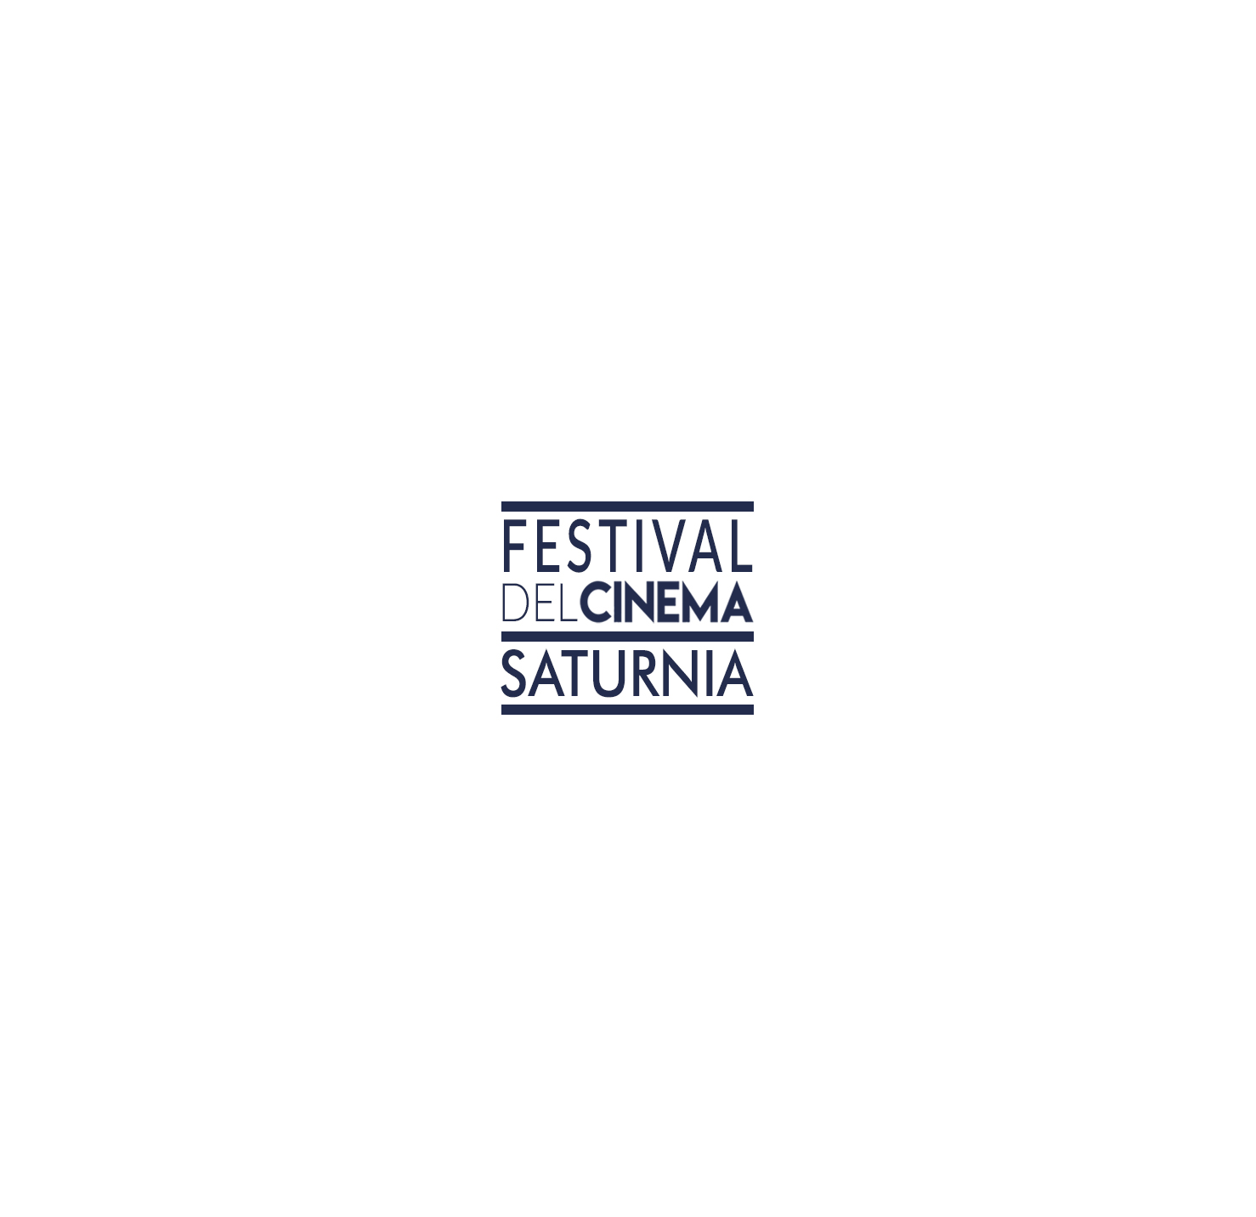

RULES & REGULATIONS FOR SUBMISSION TO THE 2018 SATURNIA FILM FESTIVAL
The cultural association “Aradia Production”, supported by the Municipality of the city of Manciano, organizes the SATURNIA FILM FESTIVAL dedicated to the discovery of the best short films from around the world.
Projects submitted for consideration for the Saturnia Film Festival may apply in one of three submission categories: Fiction, Animation, Documentary. The most prestigious award is “Premio Michelangelo Antonioni” for Best Directing. In order to qualify, short films must have a maximum duration of 20 minutes, including credits.

ART.1
OUR MISSION
The Saturnia Film Festival seeks to discover, support, and inspire independent film and theatre artists from around the world and to introduce audiences (members of the industry and film lovers) to their new work. The Artistic Commettee of the Saturnia Film Festival will consider projects that tell stories about universal themes driven by an individual and authentic voice.
ART. 2
DATE AND DURATION OF THE FESTIVAL
The Saturnia Film Festival takes place for three days, from August 31, 2018 to September 2, 2018 in the square of Manciano, the square of Montemerano, and the Terme di Saturnia (Grosseto, Italy).

ART. 3
INTERNATIONAL FESTIVAL OF SHORT FILMS
The Festival presents the best works, selected by the Artistic Commettee, in the three following submission categories:
- Fiction
- Animation
- Documentary

All directors selected will compete against one another for the most prestigious award: “Premio Michelangelo Antonioni” for Best Directing.

ART. 4
PREMIO MICHELANGELO ANTONIONI
The Saturnia Film Festival most prestigious award for Best Directing aims to honour the Master Michelangelo Antonioni, considered one of the greatest directors in Film history. His works are cornerstones of Italian and international filmmaking. Antonioni received numerous awards throughout his carreer, including the Venice Film Festival Golden Lion (1964) and the Cannes Film Festival Palme d’Or (1966). In 1995 he also received an Academy Honorary Award.

The Premio Michelangelo Antonioni for Best Directing will be awarded by Enrica Fico Antonioni, wife of Michelangelo Antonioni, in the occasion of the last day of The Festival, in the “Parco Piscine” of the Terme di Saturnia.
The Saturnia Film Festival organization hopes that the director winning the Premio Michelangelo Antonioni will receive great opportunities for his/her directing carreer.

ART. 5
OTHER AWARDS
- The Artistic Commettee of The Saturnia Film Festival reserves the sole and exclusive right to determine eligibility of any film.
- Short films submitting to The Festival (in the categories of Fiction, Animation, Documentary) must have been completed after January 1, 2016.
- The Direction of The Saturnia Film Festival will choose a Jury of at least 5 members of the industry (including film producers), that will award the following prizes:
- Premio Michelangelo Antonioni for Best Directing, awarded by Enrica Fico Antonioni (500€ prize)
- Premio Miglior Film Fiction for Best Fiction Short Film (300€ prize)
- Premio Miglior Film Animazione for Best Animation Short Film (300€ prize)
- Premio Miglior Film Documentario for Best Documentary Short Film (300€ prize)
- Premio del pubblico (Audience Award)

ART. 6
SUBMISSION RULES AND REGULATIONS
In order to be considered by The Saturnia Film Festival, the applicant must send his or her work via email to xxxxxxx and xxxxxxxxx no later than June 30, 2018.
Submissions to The Festival are open to short films of any genre applying in one of submission categories of The Festival. The Saturnia Film Festival does not require any premiere status.
If the original language of dialogue or text featured in the film is not Italian, the preview and screening copy must be subtitled in Italian or English.

The submission fee to enter the films to The Saturnia Film Festival is 10€, for the viewing and administration of the submission process. More information available at the official Saturnia Film Festival website: www.

ART. 7
SELECTION PROCESS
- Successful entrants will be notified of their inclusion in The Festival by July 15, 2018.
- For the projects considered finalists the film owner will be asked to supply promotional material of the film (scene pictures, director’s bio, credits, trailer, info etc.). The film owner will provide all the requested material by The Saturnia Film Festival organization.
- A copy of the short film and all the material requested must be sent via wetransfer no later than July 30, 2018.
- All the material (video and/or promotional material) sent to The Saturnia Film Festival will not be returned.

ART. 8
FESTIVAL PROGRAMME
- The final selection of all films presented at The Festival and their placement in the programme is the responsibility of The Festival organization.
- If the short film original language is not Italian, it will be shown with Italian subtitles.
- Italian subtitles will be provided by The Festival organization. Producers of the selected films must provide English script not later than July 30, 2018, to enable The Festival to translate and insert on-screen Italian subtitles.
- The Festival can publish, for promotional purposes, an online and/or printed catalogue with all the presented and/or selected works.

ART. 9
GENERAL RULES
1. These Rules&Regulations are written in Italian and have been translated into English. In the event of disagreement concerning the interpretation of the regulations, the Italian version will take precedence. The Direction of The Saturnia Film Festival can rule over any matters not covered by these regulations. For any legal dispute, the only competent forum is the Court of Rome.

SATURNIA FILM FESTIVAL
Via Sassi Bianchi snc Saturnia – Poggio Murella 58014 (GR) Italy
M.
T.
WEB.

