cccp
cultural popular cinematographic circle

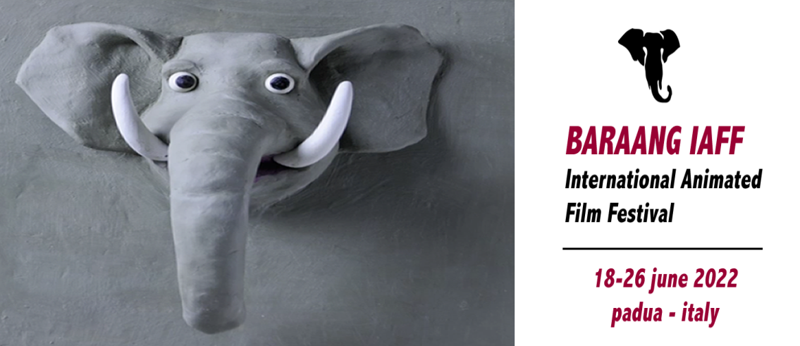
BARAAG IAFF
international animated film festival
18-26 june 2022
Padua -Italy
PROMOTER SUBJECT

BARAANG IAFF International Animated Film Festival, is organized and produced by Popular Cinematographic Cultural Circle REMAKE. The animated film festival wants to be a tribute and an encouragement to all the "visionaries" able to create situations and fantastic images, surreal and of strong visual impact, in a cross-fade between dream and reality, in the animation cinema.

OBJECTIVES

The purpose of the Festival is to research, enhance and promote audiovisual works that can make appealing to children, adolescents and even adults, their point of view on reality and their inner world, through their imagination, creativity and expression, mediated by the narrative and audiovisual language. Valuing therefore "low cost works"; animated films built using also low tech materials and free software, but with a simple but strong basic idea, that can turn into a beautiful cartoon, with a particular socio-educational value.points of view as timely as ever, involving all those "sensitive actors" of documentary film, which professionally or not, turn their attention to social problems, as an instrument investigation or course of study and research.

THE COMPETITION /REGULATION
- Conditions of participation
The competition is open to audiovisual works and short films made with animation techniques,
with no limit on the subject, type, year, country of production and duration. TV series, commercials, animated logos and similar are excluded from the competition. Works already presented at other festivals are admitted. Audiovisual works must be in Italian language or in Italian version (also subtitled).
- Sections
The 2022 edition of BARAANG IAFF international animated film festival foresees only one competitive section, dedicated to Italian and international short films made with animation techniques of any length.
- Time Period of Actuation
BARAANG IAFF international animated film festival will be held in the second fortnight of June 2022.
- Awards and Jury
The selection of the audiovisual works that will participate in the competition is by and at the unquestionable judgement of the Festival Direction, which will promptly inform the authors. The best three works will be awarded.
- Modalities of participation
To participate in the selection is necessary to connect to the page of the festival; at the end of which you will find the online pre-registration form to fill in and send. In the same page, always at the end, you can download the regulation and the registration form.
- Method of submission using SMASH or WETRANSFER, attaching:
(a) a copy of the work in relative file with avi or mpeg4 extension;
b) the entry form completed in all its parts;
c) one or more files with scene photos and the director's image in digital format and quality suitable for printing;
d) a brief synopsis of the work and brief biofilmography of the author in text format
- Postal mode, enclosing:
a) a copy of the work on DVD support and related file with avi or mpeg4 extension;
b) the application form completed in all its parts;
c) a cd-rom containing one or more scene photos of the work and an image of the director in digital format and in quality suitable for printing, a brief synopsis of the work and a brief biofilmography of the author in text format.
postal mode to the address:
BARAANG IAFF/REMAKE 2022
c/o Alfredo de Venuto
Via Francesco Marzolo, 21 - 35131 Padova - Italy
mail to: remakeccc@yahoo.it
* If missing even one of the materials required for participation in the competition, the work will automatically be excluded from the selection.

The online pre-registration must be made no later than 15 May 2022 and the material must be sent by internet or post (the postmark will do), no later than May 28, 2022.
The materials submitted will not be returned. Shipping costs are borne by the participants.
Entry to the competition is free.
Use of works
The directors, authors and rights holders of the works sent authorize the direction of the projection of the same during the Festival. Also authorize any collection of selected works in a DVD for promotional use of the festival, intended for a targeted distribution in schools, in libraries and in cultural centers without any profit motive. Finally, authorize the festival direction to keep in its copy of the work and it can be used for educational purposes, research and promotion, including in different contexts from that of the festival, to the exclusion of any commercial use and protection of the interests of the authors and producers. Participation in the selection before, and in the event of the festival took place after selection, implies full acceptance of these rules.
Padua, 29 october 2021
cccp
cultural popular cinematographic circle

