
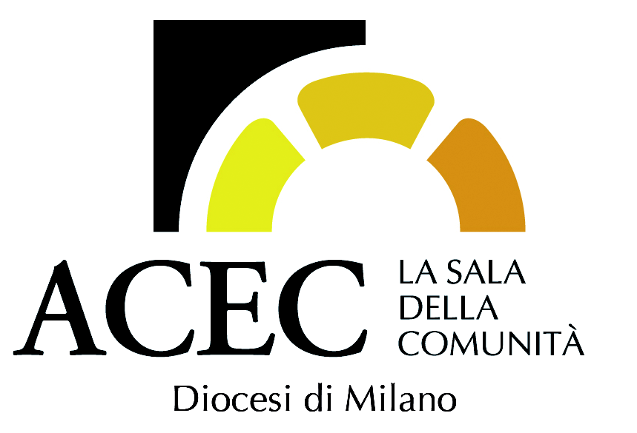
SHORT MOVIES SPIRIT

Aquerò competition, 1st edition: the invisible

Fifteen minutes to show the “spirit of cinema”.
A final evening to watch (and vote) the best works.
An high level jury, composed by cineforum magazine editor (Adriano Piccardi), cinephiles beloved weeky FilmTv editor (Giulio Sangiorgio), editor of italian highest visited website-magazine MyMovies (Giancarlo Zappoli), journalist and movie critic Alessandra De Luca (Ciak, Avvenire), with artistic director Fabrizio Tassi and ACEC Milano president Gianluca Bernardini.

Aquerò is looking for the “cinema of invisible”, in the form and in the content. Movies that have the courage to confront themselves with foundamental question (meaning, beauty, truth, justice), with depth or levity. To search, to experience, to question ourselves.

The second edition of Aquerò film festival present the international short movie competition, reserved for short movies (max 15 minutes), with a strong theme (the invisible) and an important jury representing excellence in entertainment journalism: Cineforum editor Adriano Piccardi, FilmTv editor Giulio Sangiorgio, MyMovies editor Giancarlo Zappoli, journalist and movie critic Alessandra De Luca (Ciak and Avvenire), and festival and competition artistic director Fabrizio Tassi with ACEC Milano president Gianluca Bernardini.

Aquerò hunts for talent, but mostly it is searching for a cinema that is able to narrate the inner dimension of man. To evoke the trascendental as defined by Paul Schrader; to use the creative power and digital innovation to face questions ancient like the world itself. To reason about spirituality, not in a confessional way, but secular, open, free, curious.
Aquerò is the word used by Bernadette of Lourdes to point “that”: the apparition to wich she couldnt’ yet give a name, the invisible that became image. A word that seems made to evoke presence (the incarnation) of something beyond us. We do not want to identify a style or a way of doing “spiritual cinema”, but bring to public attention movies with an unique look on the world and on the reality. Movies that face “high” and complex themes without simplify it.

Aquerò’s competition is open to works of any format and genere, published or unpublished (but made after January 1st 2018), shot in high definition or in low definition (smartphone or other device), made by professional or aspiring videomakers. You have time to participate up to 10 october 2019.
The rules and the registration form can be found on the site https://www.sdcmilano.it/acec-milano/aquero-iscrizione-concorso-cortometraggi-edizione-2019-8507.html

Finalists (minimum ten, maximum fifteen) will be chosen among all the films that have arrived that will be screened in an evening yet to be established in a cinema in Milan. Winners will also receive awards for their artistic value (1000 euros for the first, and 500 for the second), as well as the opportunity to be screened in ACEC cinemas. On the final evening the “Audience Price” will be awarded.



ACEC
The Cattolica Esercenti Cinema Association (ACEC) is a free trade association which, with no-profit purpose, implements the aims of the National ACEC with representative and administrative autonomy and therefore represents, promotes and protects the movie theatre of associated communities present in their own territory, "structures, subject however to ecclesiastical jurisdiction, which are configured as places that make multimedia (cinema, theater, music, cultural initiatives...) an instrument of pastoral action" (CEI Pastoral Note, 25 March 1999, n.33). "ACEC Milano" carries out its activity in the sectors of education and the promotion of culture and art, and operates in the field of social communication and cinema in particular, with pastoral and cultural purposes, especially in relation to the "cinema and theatre of Community ”, considered multimedia and multi-purpose structures.

