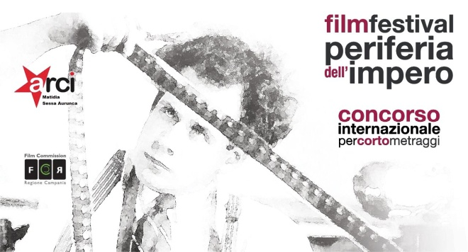

REGULATION 9th EDITION OF INTERNATIONAL SHORT FILM FESTIVAL
“PERIFERIA DELL’ IMPERO FILM FESTIVAL”
(edizione 2018)

Art.1 This is a non-profit cultural event organized by the social promotion association Arci Matidia of Sessa Aurunca (Italy), whose aim is to enhance the short cinematographic work created by independent, amateur and professional authors.
Art.2 The final event will take place in Sessa Aurunca (CE) Italy in the second half of July 2018, the dates will be communicated with reasonable notice.
Art. 3 Fiction works of any kind can take part in the competition, made by authors of any nationality, preferably in Italian or otherwise subtitled in Italian. Works created before the year 2014 or that have participated in previous editions will not be admitted to the competition. Each author can participate in the competition with only one work.
Art. 4 The competition will be open to the courts with a maximum duration of 20 min. excluding the opening and closing credits of any kind (excluding documentaries, animations and music videos), with a free theme. The festival management reserves the right to select works that hardly exceed the maximum limit allowed if they are considered highly valid. In addition, to participate in the festival you will need to pay the sum of 5 euros (five) as the registration fee in the following ways:
• Paying the sum of 5 euros by means of PayPal email address arci.matidia@libero.it
Or:
• Pouring the sum of 5 euros into the postal current account of the "Associazione Circolo Arci Matidia" iban IT65 R076 0114 9000 0101 4087 066 (convenient for postal account holders) in the reason for this, mention the title of the work and the name of the author.
Art. 5 Participants in the competition to register for the festival must send, by 24.00 on 10 June 2018, to the email address periferiadellimpero @ libero. it, a single email with the short link
(with any credentials for accessing the password) previously loaded on:
- Vimeo (via private link with password);
- YouTube
and attach (to the same email) the application form / release form (downloaded from the website www.periferiadellimpero.it filled in, signed and scanned) and the receipt of payment of the registration fee. The Management will send an e-mail reply to communicate the successful registration to the festival.
It is also possible to participate in the contest through the MOVIBETA platform by doing the search "Periferia dell’ impero", in this case it will not be necessary to make the payment separately, the registration fee will be paid through the portal itself.
A jury of experts, who will be announced on the website of the association www.periferiadellimpero.it, will view the works received and select the ones admitted at the final evenings. The authors of the finalist works will be contacted by the festival director for the sending via WE TRANSFER of a short file, in .MOV format, or .MPEG4 (codec h264, ACC or Linear PCM) max 2 GB, for advertising materials and for their eventual presence at the final evenings, will be hosted at the expense of the organization maximum two representatives (author, actors, screenwriter, etc.) for opera, which will answer questions from the press and the public present at the end of the screening of their short in competition.
Art. 6 During the final event the selected works will be screened to the public and the press, a new jury of experts (also announced on the website of the association), will award the prize to the best work and the jury prize. The public present at all evenings will be provided with a paper model with a list of all the short finalists and will be able to vote for the best work, the short which will have obtained the highest number of votes will have awarded the audience prize as the best short .
Prizes to be won (the prizes are cumulative ie a short could be awarded one of the jury awards plus the audience prize.):
1. "Best short edition 2018" award, € 500.00 (five hundred euro) + personalized plate.
2. "Public edition award 2018", € 300.00 (three hundred euros) + personalized plate.
3. "Jury Prize 2018 edition", € 300.00 (three hundred euro) + personalized plate.

In addition, the best actor and the best actress of the 2018 edition will be rewarded with a plaque and a prize in money.
Art. 7 The works admitted to the final evenings, the dates of the screening and the composition of the jury will be announced at least 20 days before on the website of the association www.periferiadellimpero.it, as well as any other communication about the competition. The prizes in money to the winners will be given by bank transfer to the author.
Art. 8 The direction of the festival may use the works received for the promotional and advertising disclosure of the competition (even after the closing of the edition), for no reason will it yield
Sessa Aurunca 19/03/2018 La Direzione del festival

