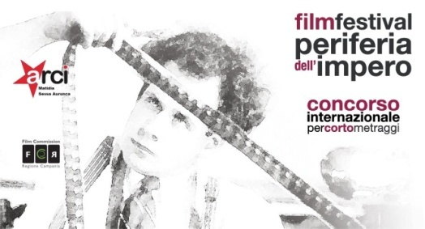

REGULATION 10th EDITION OF INTERNATIONAL SHORT FILM FESTIVAL
“PERIFERIA DELL’ IMPERO FILM FESTIVAL”
(edition 2019)

Art.1 This is a non-profit cultural event organized by the social promotion association Arci Matidia of Sessa Aurunca (Italy), whose aim is to enhance the short cinematographic work created by independent, amateur and professional authors.
Art.2 The final event will take place in Sessa Aurunca (CE) Italy in the second half of July 2018, the dates will be communicated with reasonable notice.
Art. 3 Fiction works of any kind can take part in the competition, made by authors of any nationality, preferably in Italian or otherwise subtitled in Italian. Works created before the year 2015 or that have participated in previous editions will not be admitted to the competition. Each author can participate in the competition with only one work.
Art. 4 The competition will be open to the courts with a maximum duration of 20 min. excluding the opening and closing credits of any kind (excluding documentaries, animations and music videos), with a free theme. The festival management reserves the right to select works that hardly exceed the maximum limit allowed if they are considered highly valid. In addition, to participate in the festival you will need to pay the sum of 5 euros (five) as the registration fee in the following ways:
• Paying the sum of 5 euros by means of PayPal email address: arci.matidia@libero.it
Or:
• Pouring the sum of 5 euros into the postal current account of the "Associazione Circolo Arci Matidia" iban IT65 R076 0114 9000 0101 4087 066 (convenient for postal account holders) in the reason for this, mention the title of the work and the name of the author.
• Using the Movibeta platform (expert users of the platform) doing the research "Periferia dell’impero film festival in this case it will not be necessary to make the payment separately, the registration fee will be paid through the portal it self.
Art. 5 Participants in the competition to register for the festival must send, by 24.00 on 20 May 2019, to the e-mail address: periferiadellimpero @ libero. it, a single email with the link to view the short with the ability to download (we recommend) .MOV format, or .MPEG4 (codec h264, ACC or Linear PCM) max size 2gb, however reproducible with a PC (with any credentials for accessing the password) previously loaded on:
- Vimeo (via private link with password);
- YouTube
and other similar portals as long as they allow the viewing of the short and if selected, the possibility of downloading by the end of the festival.
attach (to the same email) the application form / release form (downloaded from the website www.periferiadellimpero.it completed and signed) and the receipt of payment of the registration fee. The Management will send an e-mail reply to communicate the successful registration to the festival.
A jury of experts, who will be announced on the website of the association www.periferiadellimpero.it, will view the works received and select the ones admitted at the final evenings. The authors of the finalist works will be contacted by the direction of the festival for the sending of advertising materials by WE TRANSFER, and for their eventual presence at the final evenings, two representatives will be hosted at the expense of the organization (author, actors , screenwriter, etc.) by opera, who will be able to answer questions from the press and the public at the end of the screening of their short film in competition.
Art. 6 During the final event the selected works will be screened to the public and the press, a new jury of experts (also made known on the website of the association), will award the "Best Short of the 10th edition" Award and the " Emerging author award or first work of an author / director under the age of 30 or of any age to the first cinematographic work (short film), in this case must tick the appropriate box on the application form. The public attending all the evenings will be provided with a paper model with a list of all the short finalists and will be able to vote for the best work, the short which will have obtained the highest number of votes will have awarded the audience prize as the best short .
Prizes to be won (the prizes are cumulative ie a short could be awarded more than one prize):
1. "Best short edition 2019" award, € 1000.00 (one thousand euro) + personalized festival statuette.
2. "Emerging author award or first edition 2019 work", € 500.00 (five hundred euro) + personalized festival statuette.
3. "Public award 2019 edition", € 500.00 (five hundred euro) + personalized festival statuette.
Moreover, the best actor and the best actress of the 2019 edition will be awarded with the statuette of the festival.
Art. 7 The works admitted to the final evenings, the dates of the screening and the composition of the jury will be announced at least 20 days before on the website of the association www.periferiadellimpero.it, as well as any other communication about the competition. The prizes in money to the winners will be given by bank transfer to the author.
Art. 8 The direction of the festival may use the works received for the promotional and advertising disclosure of the competition (even after the closing of the edition), for no reason will it give to others or transmit them for audiovisual media (private web TV / TV etc. .).
Participation in the festival implies full acceptance of this regulation. The festival management reserves the right to make any decision, not foreseen by this regulation, to deal with any problems that may occur during its development. For any clarification it is possible to send the questions exclusively to the e - mail address: arci.matidia@libero.it the organization will answer in a short time.
Sessa Aurunca 15/01/2019 La Direzione del festival

